IB Business Management: www.BusinessManagementIB.com

IB Business Management – Pre-Released Case Study May 2019: Key Terms: Activity III
- Find the key terms and use the insert Endnote function in MS Word to match the term with the correct definition.
- Complete this activity and you will now have meaning in the context of the case study – genius!

List of Key Terms – alphabetical Order
- Accountants
- Accounting
- Artificial intelligence
- Automated manufacturing process
- Big data
- Brand
- Brand identity
- Business
- Business functions
- Capital expenditures
- Chief executive officer (CEO)
- Chief financial officer (CFO)
- Cloud computing
- Communicates
- Companies
- Competition
- Components
- Corporate social responsibility (CSR)
- Corporate strategic plan
- Corporate strategy
- Cost structures
- Costing
- Costs
- Customers
- Customization
- Customize
- Delivery
- Delivery costs
- Demand
- Democratic leadership style
- Design
- Division
- Economic trends
- Economy
- Employee
- Factory
- Fair wage
- Family business
- Finance
- Globalization
- Go public
- Goods
- Hierarchical
- Human resources
- Human resources plan
- Industry
- Infrastructure
- Innovation
- Loan capital
- Management
- Manufacture
- Manufacturing
- Manufacturing process
- Market area
- Market economy
- Marketing
- Marketing strategy
- Markets
- Mass produced
- Mission statement
- Mobile devices
- Nationalized
- Operations management
- Operations management strategy
- Order
- Organization (organisational structure)
- Paternalistic leadership style
- Price
- Price competitive
- Private limited company
- Private sector
- Privately-owned company
- Process innovation
- Product innovation
- Product life cycle
- Product portfolio
- Production facility
- Products
- Profits
- Raw material
- Recruits (recruitment)
- Relocation
- Services
- Share capital
- Sourcing
- Stakeholders
- State-owned company
- Teams
- Teamwork
- Three-dimensional (3D) printing
- Tooling
- Trade (international)
- Unionized
- Unionized labour force
- Vision
- Wages
- Wholesalers

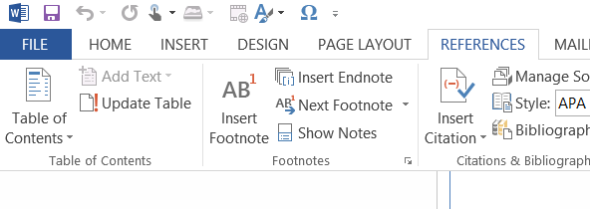

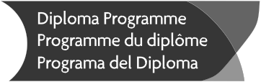
M19/3/BUSMT/BP1/ENG/TZ0/XX/CS

Business management
Case study: Radeki de Dovnic Manufacturing

For use in May 2019

Instructions to candidates

Case study booklet required for higher level paper 1 and standard level paper 1 Business Management examinations.

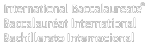

Radeki de Dovnic Manufacturing

Radeki de Dovnic Manufacturing (RDM) is 100 % owned by the Radeki de Dovnic family. RDM is located in Lobjanec, a small city in the Czech Republic. Founded in 1873, the business originally made coal-burning stoves for residences. Several decades later, RDM’s management, foreseeing the final stages of the product life cycle of coal-burning stoves,
5 also began to manufacture kerosene/oil-burning stoves. In 1949, following the Communist takeover of what was then Czechoslovakia, over 95 % of private sector commercial enterprises, including RDM, were nationalized. Following the Velvet Revolution of 1989, when Communism in Czechoslovakia collapsed, many companies moved from being state owned to privately owned. Adriana Radeki de Dovnic took over as chief executive officer (CEO) of RDM in 1990.
10 As demand for kerosene stoves had been declining for many years, in 1993, Adriana decided
to add healthcare devices using ergonomic designs* to RDM’s product portfolio. The reasoning behind the move to manufacturing medical devices was that, with the baby boomer generation soon to reach retirement age, the demand for goods and services in the healthcare industry would be growing.

15 Though not immune to broader economic trends in Europe, since the Velvet Revolution the Czech economy has fared well. Part of this success stems from the relatively smooth transition, compared to some other former Soviet bloc countries, to a stable market economy and democracy. The fact that the capital city, Prague, is one of the most beautiful cities of Europe and a magnet for tourists has also aided the economy. Traditionally, educated Czechs
20 speak German in addition to Czech, a situation that has facilitated positive trade relations with Germany, Europe’s largest economy. A small, compact country, the Czech Republic now has an IT infrastructure that ranks among the best in the world.

For many years, the head of the Radeki de Dovnic family was Dr Kristián Radeki de Dovnic
(1920–2001), a former Austro-Hungarian baron who fled Czechoslovakia in 1944 with only the
25 money in his pockets as the Soviet army advanced westward. Escaping to the United States, he earned a PhD in history and became a professor at an American university. Adriana chose to retire as CEO in 1995, giving Kristián the opportunity to return to his home country and take on the role of CEO of the family business. He eagerly accepted, even though his professional
training and experience had hardly prepared him for the task. Fortunately, his son Jan (b.1963),
30 who was born and grew up in the United States, had studied engineering at university and had long wanted to live in Czechoslovakia, which had been divided into the Czech Republic and the Slovak Republic on 1 January 1993. When Kristián died in 2001, Jan took over as CEO.

In 2002, RDM produced its last kerosene stove and now primarily manufactures healthcare devices. Jan began to introduce a highly automated manufacturing process in 2006 that was
35 operational by 2009. For most orders, customers enter desired specifications for healthcare devices into a template on RDM’s web page. An engineer then reviews the specifications. Often, engineers will contact the customer if questions arise or the engineers have identified a way of improving the design. RDM has developed several minor adaptations to customers’ products
that have made them cheaper to produce or more stable. Once the design is approved, they
40 transmit the information to accounting and marketing, which together determine the price (for the customer) of the order. A person in marketing then contacts the customer to confirm that they want to proceed with the order.

Once the customer confirms, the design specifications are transmitted electronically to the shop floor, where robots configure the tooling. A different set of robots collects and loads raw
45 material into the manufacturing process, which is done entirely by automated machinery. Only
occasionally do humans have to intervene. Highly trained engineers monitor the processes.

Two areas that have yet to be automated are the costing of products, which is mostly done the old-fashioned way by human accountants, and delivery. Jan wonders whether it will be long before self-driving lorries (trucks) will replace current human-driven ones for delivery.

50 Today, RDM is highly automated, though this situation was not always the case. For decades, RDM employed a large unionized labour force, mass produced stoves and sold its product to wholesalers. Because of globalization and fierce competition from Asian manufacturers, which had lower cost structures, in the early 2000s Jan determined that European manufacturers would have to lower costs. Automation, while requiring significant capital expenditures,
55 lowers costs in the long run. In addition, digitized communication between robots allowed RDM to be responsive to customers’ requirements. As RDM improved its automation processes and integrated cloud computing, mobile devices, big data, artificial intelligence and three-dimensional (3D) printing, its ability to customize products improved dramatically regardless of the size of the order.

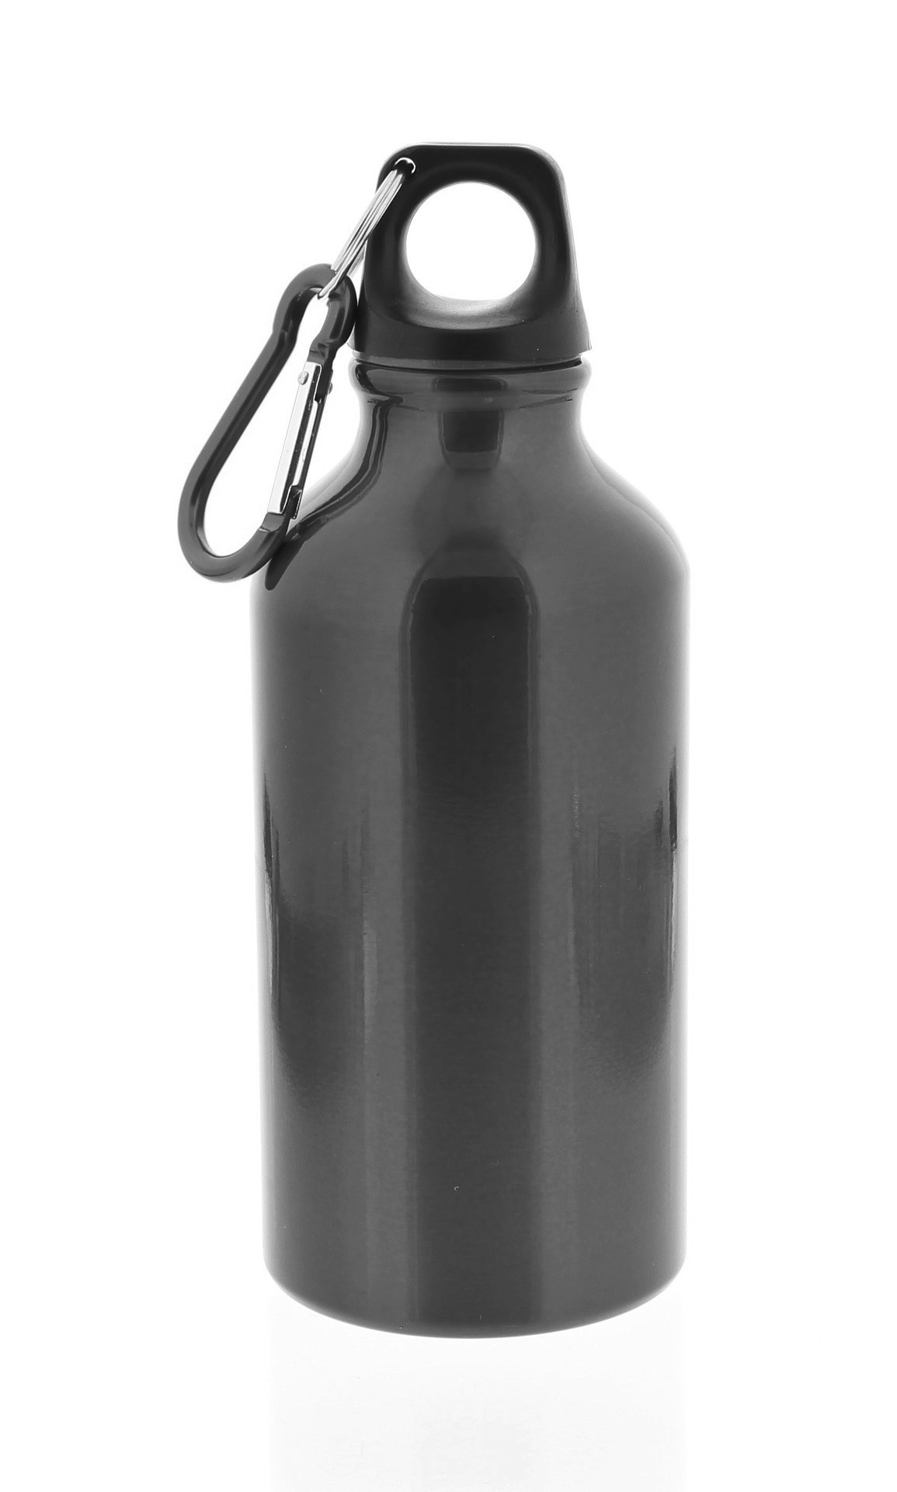
60 This integration of technologies also meant that RDM was not restricted to manufacturing healthcare devices. Rather, it could easily retool to manufacture other products when opportunities arose. For example,
one large medical customer asked RDM to manufacture 500 customized aluminium water bottles. Customization included special design features
65 of the bottles themselves as well as their colour and finish. The customer wanted to give one bottle to each of its employees. With its highly automated processes, RDM could quickly and inexpensively produce
the bottles, with different coloured bottles for the different divisions of the
company and with each employee’s name on his or her own bottle. The
70 success of the order for water bottles was such that several executives at RDM encouraged Jan to make the manufacture of customized aluminium water bottles a distinct division of the company.

RDM’s relationship with stakeholders was profoundly changed by the move to automation. In the 1970s, RDM employed roughly 500 workers, making it the largest single employer in
75 Lobjanec. In 2019, the business employs 117 people, only a small number of whom are involved in manufacturing. Further, most of those involved in manufacturing are not skilled manual labourers but highly trained engineers and computer experts who manage the automated process. Their attitudes, aspirations and motivations differ significantly from the workers who survived the Second World War and had worked under the Communist regime. With this
80 reduction in, and transformation of, RDM’s labour force, the company no longer has the level of local influence that it formerly had. The vocational school no longer liaises with RDM regarding the required skills of workers. Now, with the free movement of labour throughout the European Union, RDM recruits engineers from universities across Europe.

The move to automation also led to changes in the organization of RDM. Traditionally, the
85 business had been hierarchical. Design changes in RDM’s products, whether coal-burning or kerosene stoves, were infrequent and directed by the CEO. Now, design changes for the healthcare products come with almost every order. Teams composed of individuals from
all business functions manage orders. Jan, who replaced his father as CEO in 2001, has a democratic leadership style, which is different to his father’s paternalistic style.

Turn over

90

95

100

105

110

115

120

125
Over many years, Jan painstakingly introduced many changes in practices at RDM to create an environment of innovation. When Kristián headed the company, the environment at RDM was orderly, even dull (and somewhat depressing, as a steady stream of workers was being made redundant due to falling kerosene stove sales). Jan, however, is constantly seeking innovation
in both RDM’s products and its processes. He fosters an atmosphere conducive to creativity, with heavy emphasis on teamwork, diversity, humour and fun. Most employees love this environment, even though it sometimes seems chaotic. The atmosphere has produced positive results. However, some employees have complained that there is insufficient guidance and the business sometimes lacks focus.

RDM has always displayed a strong sense of corporate social responsibility (CSR), even before the concept of CSR became fashionable. The Radeki de Dovnic family, an old aristocratic family of the Austro-Hungarian Empire, had long held a caring and paternalistic attitude towards the people who worked for them, including the workers in their factory. Today, RDM maintains a full programme of CSR, including sourcing components from businesses who also have good CSR practices, paying fair wages and having a strong emphasis on care for the environment.

A component of the cost to customers is delivery costs, which are based primarily upon weight and distance to delivery location. Given the cost of delivery, RDM can generally offer competitive pricing in a 700-kilometre radius of Lobjanec (see Appendix 2). This 700-kilometre range means RDM can be price competitive in crucially important Germany but less so in such potentially lucrative markets as Scandinavia, the Netherlands, Belgium, France and northern Italy.

To continue to grow and access these potentially lucrative markets, the chief financial officer (CFO) has proposed that RDM build an additional production facility elsewhere in Europe, which would extend RDM’s market area. Given that the entire order/manufacture/delivery process could still be performed in Lobjanec, this new facility would require limited staff and most of the work will be done by robots. RDM can finance the expensive expansion through either share capital or loan capital. Relocation could be very expensive and may be beyond what RDM could raise as a private limited company so they may have to go public to raise sufficient finance.

Before considering the CFO’s proposal, Jan knows that one other issue must be addressed: RDM’s marketing strategy. In fact, RDM has no marketing strategy but rather a series of practices that have evolved since the Radeki de Dovnic family regained control of RDM in 1990. Arguably, RDM has no corporate strategy either, apart from a vision in Jan’s mind. He effectively communicates that vision to employees, but no written corporate strategic plan exists to achieve that vision. RDM has an outdated name, a weak brand identity, no relevant vision or mission statement and no written operations management strategy or human resources plan. The company makes good products at competitive prices and is responsive to customers’ needs. As a result, the company enjoys healthy profits for now.

Qualified persons trained in bookkeeping and in preparation, auditing and analysis of accounts. These employees prepare annual reports and financial statements for planning and decision making and advise on tax laws and investment opportunities.

