IB Business Management: www. BusinessManagementIB.com

IB Business Management – Pre-Released Case Study Nov 2017: Key Terms: Activity III
Find the key terms, and use the insert Endnote function in MS Word to match the term with the correct definition.
Complete this activity and you will now have meaning in the context of the case study – genius!
LIST OF DEFINITIONS TO LOCATE IN THE CASE STUDY AND DEFINE

Business
Break-even
Capital expenditure
Career development
Charity
Ecological sustainability
Economic sustainability
Economies of scale
Ethics
Expansion
Flat organizational structure
Grant
Labour turnover
Management
Manager
Market research
Marketing
Marketing mix
Mission statement
Operating costs
Organization chart
Organization structure
Primary market research
Professional development
Promotion
Recruitment (recruit)
Retention (retain)
Revenue expenditure

Unique selling point (USP)
Vision statement
Word-of-mouth promotion

N17/3/BUSMT/BP1/ENG/TZ0/XX/CS

Business management
Case study: Mikumi Secondary School

For use in November 2017

Instructions to candidates
Case study booklet required for higher level paper 1 and standard level paper 1 business management examinations.

3 pages
8817 –5001
© International Baccalaureate Organization 2017

Mikumi Secondary School (MSS)

5  10  15 | Jacob Wendo had always wanted to put something back into the community. He had become very wealthy owning a safari business in East Africa.  Jacob realised his dream four years ago when he set up a school for girls near to Tanztown in Central Tanzania. He called the school Mikumi Secondary School (MSS). In rural areas of Tanzania girls do not always receive good secondary schooling. Tanztown is in a remote area with mainly subsistence farming and many small villages. Per capita income is low for East Africa. The average income for the whole country is about $1000 per year, and much lower in rural areas. For many girls, continuing their education is very difficult, even though equal rights are enshrined in the constitution of Tanzania. Many girls have to work on small farms rather than receive schooling. Jacob’s school tries to provide secondary education for girls, with residential places (a boarding school). The girls’ parents pay fees that contribute  towards the operating costs of the school. Often, the parents raise money for their contribution by selling their livestock.  MSS is run as an educational charity. Jacob is the chair of trustees and takes the leading role in all aspects of the management of the school. The head teacher, Mrs Kashinga (Mrs K),  is responsible for the day-to-day running of the school, managing both revenue and capital expenditure. Mr Jones, the general manager, is responsible for non-teaching employees.  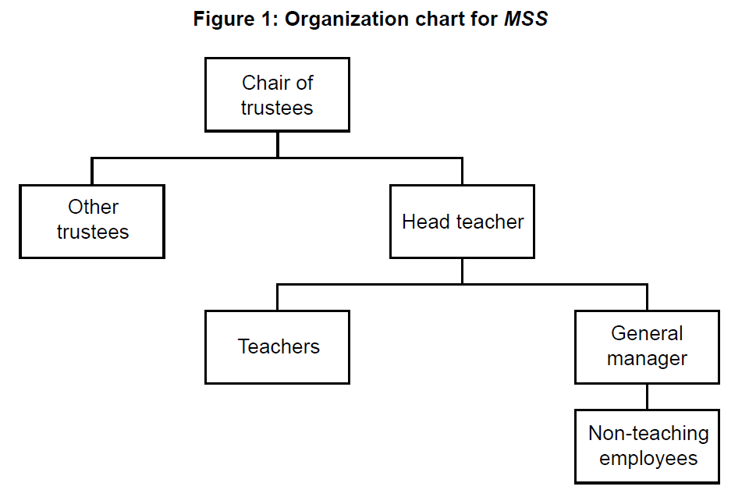  Figure 1: Organization chart for MSS  Chair of trustees  Other  trustees Head teacher  Teachers General  manager  Non-teaching employees
20 | MSS is now in its fifth year. Jacob donated the land and some buildings. The current government is supportive of the school and has provided grants. There are further donations from charities, both in Tanzania and overseas. The school and Jacob have recently received a global humanitarian award for their contribution to the development of girls’ education in the developing world.  Books for the library and some other equipment were provided by a Swedish university. The supply of electricity to the school is unreliable.

25  30  35  40  45  50  55 | Jacob wants the students to do a lot more than just study. They are very active in sports and engage in varied activities, such as singing, debating, community service and putting on drama performances. They also grow some of their own food on land that the school owns, which helps with economic and ecological sustainability. Jacob is also keen that the students are taught a strong sense of ethical values, and the whole school is managed based on ethical considerations. Results of national tests have been very good and many of the students are excited to continue their education beyond school.  Starting MSS from nothing was difficult and Jacob recognized the need for expansion in the early years to break-even. Initially, recruiting students was straightforward, but now the school needs to be marketed to a wider area, including Dodoma, the capital city. The school will have to attract girls away from some of the schools in Dodoma, and could attract students from neighbouring countries. This could achieve economies of scale. Jacob thinks that the school should produce mission and vision statements and capitalize on the very positive word-of- mouth promotion that has come from the humanitarian award. Based on some primary market research, he believes that city people will be attracted by the rural location of the school and the fees, which are about 20 % less than fees for schools in cities.  MSS pays teachers according to the standard government pay scales. However, the school  is finding it difficult to recruit and retain teachers. There is high labour turnover of about 30 %. Some of the teachers who left said that they enjoyed teaching at the school and agreed with its vision, but that the teachers’ living accommodation, which is essential because of the remote location of the school, was of poor quality. Others said that they found it difficult teaching only in English, as required for the national examinations, rather than sometimes using Ki-Swahili, which is spoken by most of the students. Some also said that there were no possibilities for career and professional development because the only possible promotion post is held by  Mrs K. The school has a flat organizational structure.  Until now, MSS has had no IT facilities, but it has recently received ten laptops from  Africa Infinity, a UK-based organization that recycles laptops for use in developing countries. The head teacher sees this as an opportunity to convert one of the classrooms into an IT centre. Few local schools have any IT facilities and an IT centre could be included in the marketing mix and become a unique selling point (USP), at least locally. The conversion of the classroom would be expensive. If only the school could get internet access…

Companies, products, or individuals named in this case study are fictitious and any similarities with actual entities are purely coincidental.

Any organisation that uses resources to meet the needs of customers by providing a product or service that they demand.
The expenses which are related to the operation of a business, or to the operation of a device, component, piece of equipment or facility. They are the cost of resources used by an organization just to maintain its existence.

